**DEVELOPMENT PROCESS**

**Research**

Relevant conventions (Web Design): **From a website**

**Below are the top 7 website conventions you should follow when designing your site:**

**1. Logo Placement**

This is a big one when following website conventions. Logos should be placed highest up on the page and 99% of the time, placed on the left side of the page. Sometimes, it’s acceptable to place the logo top centre, but when in doubt, align left. Now let’s talk size. Your logo is already in one of the most important spots on the page, so there is no need to make it bigger. The logo should also always link back to the homepage.

Why is this important?

This website convention helps users return to the homepage at any time, making the site easier to use, and aids in brand recognition. With this logo placement, users can immediately tell where they are on the web and what your site is about.

**2. Main Navigation**

Site navigation is an important website convention for users to find the information they are looking for. With that being said, the main navigation should be placed along the top of the page, either to the right of the logo or below the logo. Less is more is also important for the number of pages included in the main navigation. We suggest anywhere from 5-7 pages in the first level of navigation and no more than three levels for sub-navigation. This will prevent users from being overwhelmed with your content and help them find what they’re looking for more easily.

Why is this important?

Navigation is critical to site usability and navigation. If users [**can’t find what they’re looking for quickly**](https://www.nytimes.com/2012/03/01/technology/impatient-web-users-flee-slow-loading-sites.html), they’ll click away. Website conventions help users know immediately where and how to navigate a site, so they don’t have to hunt. There are some conventions you might bend or shirk to get creative, but this isn’t one of them. Changing navigation conventions will not only confuse users but also can affect accessibility and SEO.

**3. Content Hierarchy**

Website conventions for website content are to create a content hierarchy. This means that content should be made up of headings and paragraphs. Heading One should be used only once and at the highest up on the page. This should contain the message and value of the page. After Heading One you may have some content or you might use the second heading called Heading Two. Any subheading within Heading Two will be Heading Three and so on. Make sure these headings are keyword-focused on the page [**to aid with SEO and bring relevant visitors to your web pages**](https://www.webascender.com/blog/seo-for-wordpress/) organically through search.

Why is this important?

Proper content organization is especially important for SEO and accessibility. Web crawlers that determine where your content shows up when users enter a search use hierarchical content conventions to “understand” what a page is about. If your content organization doesn’t make sense with the web crawler’s programming, the web crawler will consider your page disorganized, less valuable to users, and therefore less likely to show up in a search.

**4. Using a Grid**

A grid system is a structure made up of a series of horizontal and vertical lines that intersect and are used to organize and arrange content and images. Not only does a grid system allow you to achieve consistency but it also creates flow and hierarchy on a page.

Why is this important?

The grid pattern for a website layout is similar to a house layout; while there are many ways to construct a house, there are a few standards that must be met, or the design starts to affect the functionality of the home. For example, ceilings must be at least a certain height, and you generally wouldn’t walk through one bedroom to get to another. A website grid pattern is similar; you can make many changes, but this organizational system helps to keep content where it makes sense.

**5. Link Styling**

Another website convention to follow is link styling. Cross-linking between pages and linking to other sources is a common practice but to differentiate link text from page text, you’ll want to use a different colour for each. Page text is usually some shade of black, whereas link text should be a brighter colour and, sometimes, bold or underlined. We typically recommend using the company’s primary or secondary colour for links.

Why is this important?

Colour contrast helps users quickly recognize links that they can click on, so they can navigate the site more easily. The general convention is black text with blue link text, but this can be adjusted, as long as there is adequate colour contrast. Avoid using colours that are too light, since they tend to get lost in white backgrounds, or colours that are too dark, as they’ll blend in with the regular text.

**6. Buttons**

Buttons should also follow website conventions. They should have some sort of background and hover effect. The background colour is typically the same colour as the link text or a secondary colour. [**Buttons should be used for more important calls to action**](https://www.webascender.com/blog/css-button-tutorial-simple-steps-create-click-worthy-buttons/) whereas link text can be used within paragraphs of information.

Why is this important?

Buttons are another part of users’ expectations. A user knows, from their previous experience, that a button leads to another page, usually on the same website. There are many ways to style buttons and, as long as the buttons use adequate colour contrast and proper sizing, users will generally recognize buttons when they see them.

**7. Colours**

Colours should be determined base on your [**company’s brand standards**](https://www.webascender.com/blog/5-design-tips-for-building-brand-identity-in-web/). But if your company does not have brand standards then we recommend using 2-3 colours and 1-3 neutrals (white, black, grey). If you need more colour then use tints and shades of the colours already chosen. This is an important website convention because it keeps your website cohesive and connects your branding on and off the web.

Why is this important?

Your colour scheme is important for brand recognition, but it’s also important for accessibility. As previously mentioned, colours without adequate contrast can be difficult to read or interpret. [**Use a colour contrast checker tool**](https://webaim.org/resources/contrastchecker/) to make sure your colour contrast is right. As long as these standards are met, there’s plenty of room to get creative

From <<https://www.webascender.com/blog/7-website-conventions-to-follow-when-designing-your-website/>>

Web hierarchy design :

<https://www.nngroup.com/articles/visual-hierarchy-ux-definition/>

This website gives several positive and negative examples of visual hierarchy

<https://www.canva.com/learn/visual-hierarchy/>

This website has good conventions for colour theory and font sizes as well as placements for the users

An example of bad visual hijack

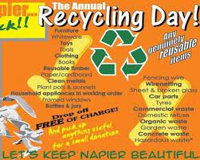

**This example makes it hard to see which info is most important as well as making the content hard to read** this slows the parsing of information from the website to the user

An example of good visual hierarchy

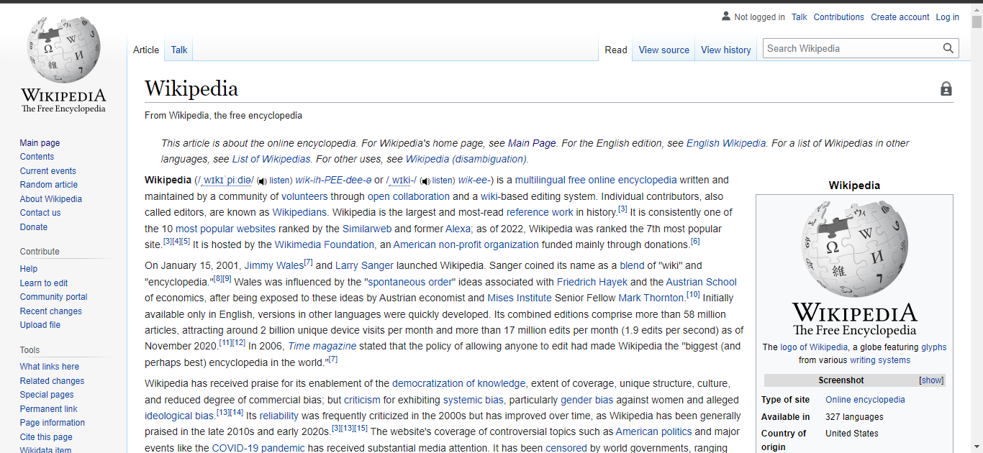

Note the content is in the centre with links on the side the logo is in the top left corner(this is standard for web design) the minimalist design highlights information which allows the user to absorb the information much faster

Design styles:  
**Single-page web design:**   
all content is placed on a single web page this design is also sorted and can still have dynamic elements and run code in the browser

**Static website:**

This webpage has no dynamic elements and tends to be very basic HTML and CSS this leads to very efficient load times and processing

**Dynamic website**

**These websites tend to have multiple pages with dynamic elements that tend to use JavaScript and browser rendering**

**Responsive design**

Can be paired with other design patterns just means it scales with screen size and resolution

**Grid layout:**

The elements of the web page are styled in a series of boxes e.g., YouTube, Netflix, etc

 The Zig-Zag Layout

Research revealed how users use to scan a webpage content: the eyes move along the page following a Z

**Plan**

Mind map:

See chemsite.pdf

Point of view statement:

Many neca students take chemistry and waste a lot of time looking for course rescores making this faster will make studying easier

**Relevant Conventions**

|  |  |  |
| --- | --- | --- |
| **Implication** | **How relevant is it?** | **Explain** what the implication is and what it means  **Why** is it **relevant**to **your design?**  **How** will it affect your design? |
| intellectual property | very relevant | I will find open-source public resources and cite my sources so as to not violet intellectual property laws or unfairly claim that any work done by others is my own |
| usability | very relevant | I will follow the guidelines for web development that are used for usability this is because the if the website is not usably then the students will not use it making the entire project a large waste of time |
| functionality | Somewhat relevant | I will make sure to test my design as much as possible to ensure that it works successfully ensure that the website functions as well as possible to make sure that the students can learn as quickly as possible |

**Testing Procedures**

I used these procedures to test my outcome (Highlight those used)

Testing end users,

Testing code across multiple browsers e.g. chrome and Firefox,

And testing functions independently (said functions are not included in this submission)

I got the following feedback from my end users:

Several of the users that I used to test my website commented on 5 key areas for improvement in the build

1. Change the colours the first build of the website used very oversaturated colours that many of my test users complained about I updated these colours to be more pleasing to the eye
2. Some of the test users stated that it was hard to evaluate the website without any content, so I ran some tests with fake content to make the tests more accurate
3. Many of them highlighted that serval of my websites proposed features had yet to be implemented and so their criticism would be incomplete I saw no real way to resolve these issues
4. Finally the last major concern that the users had was about the lack of interesting things around the site in my option this is good as it forces the users to focus on their study and work

After getting this feedback I changed my design by:

Toned down the saturation of the colours used on the website as well as making serval different layouts (I included the three most popular layouts)

I tested users with versions with fake content to see if the design held their attention

And finally I simplified the overall design and removed visual clutter for a better user-experience

**Design**

**Tools and Techniques I have used in my development:**

|  |  |
| --- | --- |
| Advanced Techniques (Highlight those that are evident) | |
| creating or customising scripts, code or presets | Used combination of steps to manipulate or enhance elements |
| using composite effects. | using a third-party library |

|  |  |
| --- | --- |
| Efficient Tools and Techniques (Highlight those that are evident) | |
| management of assets | reusing objects, styles and/or frames |
| using stylesheets | html/CSS validation procedures |
| master pages or student developed templates | optimisation of media assets. |
| commenting | character formatting controls |
| Conventions include: | |
| Externalising scripts and CSS to other files | HTML validators |

**Explain how you used these and how this helped you develop your product**

**I wrote all my html, CSS, and JavaScript from scratch this was to allow me to have the most control over the outcome of my website because of this I was forced to stack serval different CSS functions on top of each other to get the exact outcome that I wanted for the website**

**By making my CSS external to the page I was able to use the same CSS to style multiple pages this allowed my code to follow the principle of DRY (do not repeat yourself) this lowers the overall size and complexity of the code and will make it easier to maintain in to the fuhcer**

**I also made the decision to host all the media assets used by the webpage off site so that the media was easier to mange**

**For project management I used a Trello board to implement the agile project management system**

**(**[**https://trello.com/invite/b/aozer1S8/ATTI8aded4629bc38fd500531ff9987e5afaFC138467/website-for-school**](https://trello.com/invite/b/aozer1S8/ATTI8aded4629bc38fd500531ff9987e5afaFC138467/website-for-school)**)**

**As well as this I set myself deadlines that would maintain my momentum while I was developing the project. These tools helped to keep me focused on the overall picture and not get bogged down in the minutia**

**Review** **of Iterative Development**

Explain how you made iterative improvements throughout the design, development, and testing process to produce a high-quality outcome. Include screenshots and feedback from users.

The use of Iterative Development helps me to implement much of my user’s feedback as well as letting me work towards following the relevant implications such as getting three versions of the website (after several iterations) that I can choose from that fellow all of the criteria I set out for the website (that it should be user friendly, make the user focus, on learning chemistry and that it should not be visual repulsive.

The most useful part of the iterative design process is that it showed how smilingly complete features could be improved upon to make the overall experience better for both the designer/programmer and the user without iterative development I feel that my final outcome would have been far worse than what it would have been otherwise.